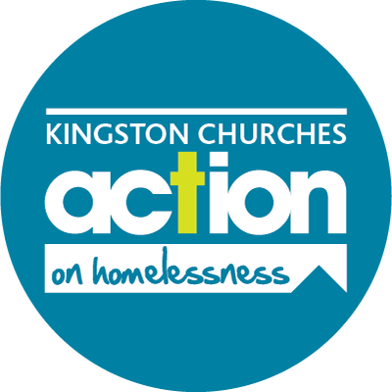
Kingston Churches Action on Homelessness
St Peter’s Church Hall, London Road, Kingston upon Thames, KT2 6QL
Company Limited by Guarantee
Registered Charity No. 1075890 Registered Company No. 3735702

JOB DESCRIPTION

Job Title: Housing Advisor

Hours: 36 (9.00am – 5.00pm)

Salary: £25,700 - £28,500 pa (depending on experience)

Location: St Peter’s Church Hall, London Road, Kingston upon Thames,
Surrey KT2 6QL

Reporting to: Senior Housing Advisor

Main purpose of the job:

The Housing Crisis Intervention Service (HCIS) is the first point of contact for anyone approaching KCAH for help with a housing problem or who is homeless.

Working alongside up to two other Housing Advisors and overseen by the Senior Housing Advisor who is the most senior in advice work, this post is responsible for the provision of quality advice covering all relevant housing options. The advice areas focus on housing law and welfare benefits. This is provided during a drop-in service in the morning with arranged appointments for complex cases in the afternoon. The role also involves making referrals to suitable housing opportunities and acting as an advocate where appropriate.

Specific focus is given to supporting our visitors to the drop-in service. As well as providing advice, this post is also about understanding the reasons why the person is in housing crisis. Recognising that our visitors often need to improve their health and well-being and their ability to cope through this difficult time, ensures the success of the service. Delivery of holistic support alongside finding housing solutions means that KCAH works to create lasting change in the lives of people who come to us at a critical moment.

SPECIFIC DUTIES

- Create and Contribute to a Person-Centred Approach

- Work towards creating a trusting relationship with each client from the very first ‘welcome’ and always with the understanding that wraparound support goes hand-in-hand with finding appropriate housing solutions for the person in crisis, with an appreciation of ‘trauma-informed care’ at all times.

- Advice and Advocacy

- Provide quality housing information, advice and representation to people who register with KCAH who are homeless or threatened with homelessness. Responding effectively to any emergency situations, particularly when clients are rough sleeping to ensure appropriate referrals are made to outreach services or accommodation services if available.

- Provide advice and support on Welfare Benefits matters. This includes making effective applications, reconsiderations and submissions when attending tribunals on behalf of clients.

- Maintain an up-to-date working knowledge of the law and policy and procedures relevant to housing and welfare benefits advice, through training, publications and general research.

- Managing your own caseload of clients, collaborating closely with other team members and volunteers

- Delivering compliance and quality work across our casework provision, including obtaining quality standards, supporting client feedback mechanisms, and adhering to policy compliance

- Work sympathetically and effectively with clients, some of whom may be experiencing considerable stress, have a mental health or substance misuse diagnosis.

- To manage shared caseloads and administration where the tasks include:

  - Keeping accurate, detailed, computerised case notes and records as well as carrying out all necessary administration and maintenance of statistics/data required by the line manager which will be on a monthly basis.

  - Evaluating and prioritising cases, making decisions on appropriate options, including advising on any legal action that may be required. Completing referrals to appropriate agencies.

  - Being flexible and adaptable to cases on an individual basis, including lone working, home visits and accompanying clients to external interviews.

  - Advocating, corresponding and negotiating with a wide range of people to include: clients, landlords, solicitors, councillors, local MPs, council officers and other agencies, particularly stakeholders from the voluntary and statutory services. Collaborative working with Kingston Probation to help offenders resolve housing issues is a key element to this work.

  - Liaising closely and develop close relations with relevant external agencies for the purposes of referral, liaison, information exchange, project work and training to ensure wherever possible they are fully aware of the services provided by KCAH.

- Administration

- To work as part of the team of staff and volunteers and assist with the general office administration, filing, clerical work in co-operation with others. Offering support if required and at all times ensure the quality of service is maintained.

- Ensure all client data is collected accurately on the computer case management system and provide information needed to compile statistics for KCAH and its funders. This includes the collation of data through questionnaires, focus groups, case studies and capturing audio and visual stories.

- Complete casework and attend external case reviews to ensure advice is accurate and meets the standards of The Advice Service Alliance Standard so that KCAH maintains its Advice Quality Standard for housing and welfare benefits advice.

- Prepare and maintain up-to-date information resources for clients and external agencies.

- Complete any training courses requested by KCAH and filter information to other colleagues ensuring full and regular liaison occurs with all other areas of the Charity.

- To have full awareness of KCAH policies and procedures and maintain them in all work activities.

- To undertake any other duties commensurate with the requirements of the post.

